Epsom & Ewell
9
v
Bedfont & Feltham
Saturday, 14th December 2019 – 3.00 p.m.
Good afternoon and welcome to High Road for our latest Combined Counties League match against Bedfont & Feltham. We welcome their players, supporters and the match officials and hope they have a safe journey home.

We have had some very memorable matches against our opponents during their short existence as a merged club and in addition to a 9-2 win there a few years back we achieved an equally unusual 6-4 win last April. Their last visit here just over a year ago was also a mad game and ended in a 4-4 draw! They had a slow start to the season but are in good form currently and as I write this, sit in the coveted top four spots. Of course they also defeated us 3-1 back in October in the Division One Cup at the Orchard.

Following the postponement of our last home match against Sandhurst Town, which is now to be played on Tuesday 28th January, I have some recapping to do. Just before that match was due, we played out an entertaining 2-2 draw at home to Dorking Wanderers Reserves, recovering a two goal half time deficit. We then followed this with a fine performance in winning 2-0 at Godalming Town two weeks ago today, but last Saturday we then visited Fleet Spurs and suffered another defeat by two goals to one, which leaves us in sixteenth place in the table.

We then followed this with a Monday night trip to Gander Green Lane for a Surrey Premier Cup tie with Sutton United’s Development squad, and we were completely dominant, winning 7-0 against a team who were former winners of the cup in recent years. Rob Hendry scored our first hat trick of the season and Bobby Bennett got two as we earned a home tie with Nottsborough in the Second Round. They are a very strong Southern Amateur League team who have reached the final in both of the last two seasons, and winning it in 2017/18, so this will be a real challenge.

Going forward, we visit Eversley and California this coming Saturday and then in between Christmas and the New Year we host Westside on Saturday 28th December to close out a disappointing 2019.

As this is our last match before Christmas, we take this opportunity to wish everyone a Happy Christmas and a great New Year.

Enjoy the game!

Rich
You can follow us on social media – just see the inside cover for details.

Cover photo by Gemma Jarman

The team pose for the cameras at their hotel
in Jersey on the Sunday morning after our match

Cherry Red Records Combined Counties League
Division One Table 2019/20
incl Saturday 7th December | P | W | D | L | F | A | Pts | GD | H | A

Jersey Bulls | 18 | 18 | 0 | 0 | 69 | 5 | 54 | +64 | 13/4 | 0-2
Farnham Town | 16 | 10 | 3 | 3 | 31 | 16 | 33 | +15 | 0-2 | 15/2
Tooting Bec | 16 | 9 | 4 | 3 | 39 | 20 | 31 | +19 | 2-2 | 1-2
Bedfont & Feltham | 17 | 8 | 3 | 6 | 38 | 28 | 27 | +10 | 14/12 | 18/4
Kensington & Ealing Boro | 16 | 9 | 0 | 7 | 38 | 33 | 27 | +5 | 21/1 | 1-3
Walton & Hersham | 15 | 8 | 2 | 5 | 43 | 28 | 26 | +15 | 31/3 | 3-6
AFC Hayes | 16 | 8 | 2 | 6 | 41 | 32 | 26 | +9 | 1-4 | 18/1
Sandhurst Town | 15 | 7 | 4 | 4 | 31 | 24 | 25 | +7 | 28/1 | 14/3
Fleet Spurs | 17 | 8 | 0 | 9 | 32 | 33 | 24 | -1 | 3-5 | 1-2
Dorking Wanderers Res | 19 | 7 | 3 | 9 | 40 | 46 | 24 | -6 | 2-2 | 11/4
British Airways | 18 | 6 | 4 | 8 | 28 | 42 | 22 | -14 | 11/1 | 29/2
Cove | 17 | 6 | 4 | 7 | 30 | 50 | 22 | -20 | 25/1 | 2-2
Ash United | 18 | 7 | 0 | 11 | 29 | 46 | 21 | -17 | 8/2 | 2-1
Westside | 16 | 6 | 2 | 8 | 33 | 29 | 20 | +4 | 28/12 | 3-1
FC Deportivo Galicia | 18 | 5 | 4 | 9 | 22 | 45 | 19 | -23 | 3-0 | 1/2
Epsom and Ewell | 17 | 5 | 3 | 9 | 32 | 38 | 18 | -6 | x | x
Bagshot | 15 | 5 | 2 | 8 | 23 | 35 | 17 | -12 | 4/4 | 1-2
Godalming Town | 16 | 3 | 3 | 10 | 28 | 46 | 12 | -18 | 5-2 | 2-0
Chessington & Hook Utd | 13 | 3 | 5 | 5 | 20 | 25 | 11* | -5 | 22/2 | 14/1
Eversley & California | 17 | 1 | 4 | 12 | 15 | 41 | 7 | -26 | 21/3 | 21/12
* Chessington & Hook United – 3 points deducted for playing an ineligible player on 3rd August v Godalming Town

Lucky Day? – 14th December
Played 13 - Won 5 Drawn 2 Lost 6 - For 24 Against 24 - PPG 1.31 - Average
Our Club record against Bedfont & Feltham
v Bedfont & Feltham: Played 6 - Won 4 Drawn 1 Lost 1 - For 26 Against 15 - PPG 2.17 - Very Good
v Bedfont: Played 10 - Won 6 Drawn 2 Lost 1 - For 21 Against 14 - PPG 2.22 - Fantastic
v Feltham: Played 31 - Won 13 Drawn 10 Lost 8 - For 50 Against 31 - PPG 1.58 - Above Average
Our Largest wins and losses against Bedfont & Feltham
Tuesday, 2nd August 2016 - W 9-2 - Combined Counties League (A)
Tuesday, 1st October 2019 - L 1-3 - Combined Counties League Division One Cup (A)
Bedfont & Feltham‘s Last Visit
Saturday, 8th December 2019 - Drew 4-4 - Combined Counties League

First Eleven Appearances - (max 21)
Name | Debut | 2019/20 |  |  |  | Career Totals
 |  | App | Sub | Tot | Goals | App | Sub | Tot | Goals
BENNETT Bobby | 12/08/2018 | 16 | 3 | 19 | 9 | 57 | 3 | 60 | 32
BETANCOURT Steve | 18/08/2018 | 1 | 2 | 3 | 1 | 22 | 3 | 25 | 2
BONASS-WARD Joe | 10/08/2019 | 13 | 2 | 15 | 0 | 13 | 2 | 15 | 0
CARNEY Billy* | 12/01/2019 | 1 | 2 | 3 | 2 | 13 | 7 | 20 | 8
CARTON Kyle* | 03/08/2019 | 4 | 0 | 4 | 0 | 4 | 0 | 4 | 0
CHIN Louis* | 08/12/2018 | 6 | 1 | 7 | 0 | 19 | 2 | 21 | 0
CONNELLY Lloyd | 14/10/2017 | 19 | 1 | 20 | 2 | 97 | 5 | 102 | 8
DAVIES Felix* | 03/08/2019 | 11 | 0 | 11 | 0 | 11 | 0 | 11 | 0
FRAY James | 12/11/2019 | 4 | 0 | 4 | 0 | 4 | 0 | 4 | 0
FUNNELL Toby | 03/08/2019 | 13 | 1 | 14 | 1 | 13 | 1 | 14 | 1
GALLAGHER Jordan* | 07/08/2016 | 8 | 2 | 10 | 3 | 57 | 15 | 72 | 21
HAYWOOD-ROYE Corey | 30/11/2019 | 1 | 1 | 2 | 0 | 1 | 1 | 2 | 0
HEAGNEY Adam | 16/08/2016 | 13 | 0 | 13 | 1 | 127 | 13 | 140 | 4
HENDRY Rob | 08/08/2015 | 11 | 7 | 18 | 7 | 121 | 31 | 152 | 53
KING Jahmahl | 26/10/2019 | 7 | 0 | 7 | 0 | 7 | 0 | 7 | 0
LEWIS Rory | 03/08/2019 | 1 | 1 | 2 | 0 | 1 | 1 | 2 | 0
MARTIN Chaz-Lee | 03/08/2019 | 8 | 0 | 8 | 2 | 8 | 0 | 8 | 2
MORGAN Sam | 11/09/2018 | 0 | 1 | 1 | 0 | 3 | 10 | 13 | 0
MURPHY Scott | 20/01/2007 | 19 | 0 | 19 | 4 | 110 | 2 | 112 | 13
MURPHY Todd | 27/11/2018 | 11 | 0 | 11 | 0 | 14 | 9 | 23 | 0
NIGHTINGALE Zak* | 03/08/2019 | 3 | 4 | 7 | 1 | 3 | 4 | 7 | 1
PINDER Marlon* | 13/01/2018 | 5 | 0 | 5 | 3 | 18 | 1 | 19 | 5
ROBERTS Liam | 12/08/2017 | 4 | 9 | 13 | 3 | 54 | 30 | 84 | 20
ROBINSON Jake | 23/02/2019 | 13 | 3 | 16 | 1 | 22 | 4 | 26 | 1
SMITH George | 16/11/2019 | 1 | 1 | 2 | 0 | 1 | 1 | 2 | 0
SMITH Taryn | 28/10/2017 | 12 | 3 | 15 | 2 | 26 | 14 | 40 | 7
STRAKER Tariq | 16/11/2019 | 5 | 0 | 5 | 1 | 5 | 0 | 5 | 1
SULLIVAN Ryan* | 04/08/2018 | 1 | 0 | 1 | 0 | 31 | 2 | 33 | 0
TEIXEIRA Ricardo* | 19/10/2019 | 4 | 0 | 4 | 0 | 4 | 0 | 4 | 0
THOMPSON Ashley* | 21/08/2017 | 1 | 0 | 1 | 0 | 36 | 1 | 37 | 5
WHITE Sean* | 02/08/2014 | 9 | 4 | 13 | 0 | 38 | 29 | 67 | 9
YOUNG Conor | 07/03/2015 | 6 | 0 | 6 | 0 | 67 | 0 | 67 | 0
* Player has left the club

Latest Results and Fixtures
Combined Counties League Cup 2nd Round – Tuesday 19th November
Abbey Rangers | 1-0 | Raynes Park Vale
Esoteric Division One Cup 2nd Round – Tuesday 19th November
Walton & Hersham | 1-0 | AFC Hayes
Combined Counties League – Tuesday 19th November
Ash United | 2-1 | Westside
Eversley & California | 2-2 | Godalming Town
Combined Counties League – Saturday 23rd November
Bedfont & Feltham | 1-1 | Godalming Town
Epsom & Ewell | 2-2 | Dorking Wanderers Res
Farnham Town | 0-1 | AFC Hayes
Fleet Spurs | 2-0 | British Airways
Jersey Bulls | 7-0 | Cove
Tooting Bec | 3-0 | Ash United
Combined Counties League – Saturday 30th November
AFC Hayes | 4-2 | Westside
Ash United | 2-1 | Kensington & Ealing Borough
British Airways | 2-0 | Dorking Wanderers Reserves
Cove | 2-1 | Tooting Bec
Eversley & California | 0-2 | Fleet Spurs
FC Deportivo Galicia | 2-4 | Bagshot
Godalming Town | 0-2 | Epsom & Ewell
Jersey Bulls | 4-0 | Farnham Town
Sandhurst Town | 2-5 | Bedfont & Feltham
Combined Counties League Cup 1st Round – Tuesday 3rd December
Spelthorne Sports | 6-2 | Chessington & Hook United
Combined Counties League Cup 2nd Round – Tuesday 3rd December
Badshot Lea | 0-2 | Dorking Wanderers Reserves
Esoteric Division One Cup 2nd Round – Tuesday 3rd December
Fleet Spurs | 3-1 | Westside
Combined Counties League – Tuesday 3rd December
Bedfont & Feltham | 3-0 | Cove
Eversley & California | 1-1 | Farnham Town
Combined Counties League – Saturday 7th December
Ash United | 2-1 | Eversley & California
Bagshot | 3-1 | Westside
Bedfont & Feltham | 3-0 | FC Deportivo Galicia
Chessington & Hook United | 0-2 | Farnham Town
Fleet Spurs | 2-1 | Epsom & Ewell
Godalming Town | 3-4 | Cove
Kensington & Ealing Borough | 3-2 | AFC Hayes
Sandhurst Town | 4-0 | British Airways
Tooting Bec | 0-1 | Jersey Bulls
Walton & Hersham | 3-4 | Dorking Wanderers Reserves
Surrey Premier Cup – Monday 9th December
Sutton United Development | 0-7 | Epsom & Ewell
Latest Results and Fixtures
Combined Counties League Cup 2nd Round – Tuesday 10th December
Banstead Athletic | V | AFC Hayes
Camberley Town | V | Colliers Wood United
CB Hounslow United | V | Balham
Combined Counties League – Tuesday 10th December
Cove | V | Bagshot
Farnham Town | V | Fleet Spurs
Kensington & Ealing Borough | V | Chessington & Hook United
Sandhurst Town | V | Ash United
Tooting Bec | V | Bedfont & Feltham
Combined Counties League – Saturday 14th December
AFC Hayes | V | Chessington & Hook United
Bagshot | V | Kensington & Ealing Borough
British Airways | V | Ash United
Cove | V | Fleet Spurs
Dorking Wanderers Reserves | V | Farnham Town
Epsom & Ewell | V | Bedfont & Feltham
FC Deportivo Galicia | V | Sandhurst Town
Jersey Bulls | V | Godalming Town
Walton & Hersham | V | Tooting Bec
Westside | V | Eversley & California
Combined Counties League – Tuesday 17th December
Bagshot | V | Farnham Town
Chessington & Hook United | V | Ash United
Kensington & Ealing Borough | V | Godalming Town
Combined Counties League – Wednesday 18th December
Westside | V | Sandhurst Town
Combined Counties League – Saturday 21st December
Ash United | V | Jersey Bulls
Bedfont & Feltham | V | Westside
Chessington & Hook United | V | British Airways
Dorking Wanderers Reserves | V | FC Deportivo Galicia
Eversley & California | V | Epsom & Ewell
Farnham Town | V | Godalming Town
Fleet Spurs | V | Bagshot
Kensington & Ealing Borough | V | Cove
Sandhurst Town | V | Walton & Hersham
Tooting Bec | V | AFC Hayes
Combined Counties League – Saturday 28th December
Bagshot | V | Bedfont & Feltham
British Airways | V | Eversley & California
Chessington & Hook United | V | Tooting Bec
Cove | V | Sandhurst Town
Epsom & Ewell | V | Westside
Farnham Town | V | Jersey Bulls
FC Deportivo Galicia | V | Kensington & Ealing Borough
Godalming Town | V | Fleet Spurs

From behind the goal
Jersey Bulls 2-0 Epsom & Ewell
Combined Counties League Division One - Saturday 16th November 2019

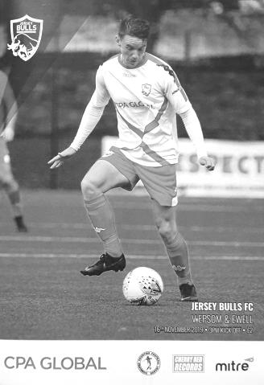
Jersey trip ends in narrow defeat

Back in May 2013, we made our first journey to the Channel Islands as guests of Guernsey. Six years on we visited the neighbouring island of Jersey, but the result was identical to the one we received back then, as a late goal in each half resulted in a 2-0 defeat against a very solid Jersey Bulls team.

Jersey have conceded just five goals in fifteen league matches, so chances were always going to be at a premium, although hopes were raised slightly when we were made aware that a number of their regulars would be missing from this match on representative duty. However, as the morning dawned and the players met at Gatwick just after 6.30 a.m. on the morning of the match, it was apparent that we were missing a number of our own regulars, with Chaz-Lee Martin, Adam Heagney and Sean White injured, Jake Robinson ill and Marlon Pinder away.

Coming into the squad and making their debuts were Tariq Straker and George Smith, while returning to the club after a spell at Bedfont & Feltham was Steve Betancourt and he was joined by our returning traveller Conor Young who was back between the posts. All would see action on the artificial surface at the Springfield Stadium; an unusual venue with one enormous stand that housed everything from players facilities to a café, but with a giant green cage around the rest of the pitch, which may well prove to be an issue once they join the higher ranks as they surely will. Fortunately, with nearly a thousand seats available in the stand there would be room for everyone and 661 were present to see an understandably defensive set up from the Salts in the opening stages, with five men at the back and only Rob Hendry ploughing a lone furrow up front, despite suffering from a groin injury that would require his removal later in the match.

This tactic worked fairly well for a while as the hosts probed but rarely threatened. An early scare came in the third minute when a free kick was headed wide by an unmarked player before they hit the post in the tenth minute. The ball rebounded straight back into Young's arms, but the flag had gone up for offside by that point anyway, so wouldn't have counted as the player who was offside when the shot came in was in Young's line of vision. Smith made things difficult for himself in the 17th minute after he mistimed a tackle and picked up a yellow card in the process but there was little of real concern going on in our box as the centre backs of Todd Murphy, Jahmahl King and Lloyd Connelly mopped up any real danger.

It also has to be said that we created little to this point, largely due to our defensive formation which occasionally freed Bobby Bennett and Taryn Smith to support Hendry from either flank, but not as often as would normally be the case and James Fray, operating in central midfield, was the first to strike a shot at the home goal, but it missed the target.

As we approached the half, the home side exerted a bit more pressure, although Young still hadn't had a save of any difficulty to make until a right wing cross was blocked by the arm of Todd Murphy and a penalty was awarded. I'm informed that the ball was going straight at his face and he raised his hand in protection, but of course, that will always be seen by the officials as "hand to ball" and the Bulls Captain for the day Jay Giles scored the penalty in the 44th minute, although it wasn't the best strike and Young almost kept it out, almost diving past the ball before reaching back and half blocking the ball which then dribbled over the line almost apologetically.

It was unfortunate that we had not quite seen the half out, but we were nearly level four minutes into the second half, albeit in controversial circumstances when a dangerous ball in from Straker was met by Hendry ahead of the keeper, and he knocked the ball onto the bar and away. However, he had actually punched the ball onto the bar, but this was not spotted and it was clear that had the ball gone into the net it would have been given!

With the match still at just one-nil the game remained in the balance and the home side tried to extend the lead, breaking away from the Hendry crossbar incident and forcing Young into a good save. In the 53rd minute our keeper was involved again after a clearance fell kindly for Gabbiadini, but again the shot was turned around the near post with the resultant corner ending with a shot that was well over the bar from the same player.

Six minutes later Young did his best work as Baker broke through on goal, but our keeper stood up well as he has so often done in the past, and denied the striker with a good block. In response Smith and Straker struck at goal but both attempts were wide and in the 83rd minute Young saved well from Wilson.

We were beginning to threaten a little more as the game entered its closing stages though and King was not far over the bar with his long range effort while in the 89th minute Smith struck the post with a powerful effort from an angle. If this was unlucky then in the 92nd minute a dangerous ball in forced Connelly to get there ahead of a striker, but his touch beat Young and went into his own net for the second Bulls goal. This was particularly harsh as we were down to ten men at the time, following an injury to Straker that required his replacement by Sam Morgan, but the change only came after the goal and soon after this the final whistle blew.

Over the course of the ninety minutes the home side deserved the win. Young was far busier than the home keeper and on another day, another couple of goals could have been scored, matching up with the Bulls average of four goals a game. In return though, it could also be argued that Smith's strike was ever so close to rescuing a point and that would have been quite an achievement. Still, performances like this are more encouraging than the recent ones at Kensington and Walton so it is hoped we can now push on and start climbing the table. With four promotion places on offer at the top of the table, no one wants to miss the flight, even though one of our players nearly did just this on Sunday morning. Last call for Taryn Smith!!

Epsom and Ewell; Conor Young, George Smith, Tariq Straker, Todd Murphy,
Lloyd Connelly, Jahmahl King, Bobby Bennett, Scott Murphy (c), Rob Hendry,
James Fray, Taryn Smith

Sub: Steve Betancourt for Smith (61), Joe Bonass-Ward for Hendry (81),
Sam Morgan for Straker (93)

From behind the goal
Epsom & Ewell 2-2 Dorking Wanderers Reserves
Combined Counties League Division One - Saturday 23rd November 2019

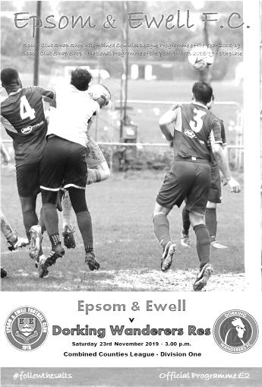
Salts recovery obscured by officiating

After four straight defeats, a 2-2 draw against Dorking Wanderers Reserves was an acceptable result, especially bearing in mind that we fought back from 2-0 down at the break. However, whilst this match will mostly be remembered for a very poor officiating performance, we still have to address a poor first half where we did ourselves no favours either.

We made only one change from the eleven who battled well at Jersey Bulls with Marlon Pinder returning to the team in place of George Smith who was on the bench, but against a team containing two former Salts as players and another; a member of our League Cup winning team Carl Downs as Manager, we got off to a very sluggish start. The first ten minutes were concerning as we struggled to make any headway at all. Fortunately the three shots on goal that the visitors had were off target. It wasn't until the 15th minute that we fashioned our first chance when a clever pass put Taryn Smith through on the left, but from fifteen yards he was also off target with a left footed effort that cleared the bar.

A dangerous ball in from the right was cleared from in front of our posts by Jahmahl King, making his home debut after playing four matches away from High Road and a few minutes later, some good interplay between Bobby Bennett and another recent signing James Fray resulted in a decent near post cross from the latter but Rob Hendry was unable to guide the header on target. It would prove to be about the only header we would win in the attacking third of the pitch as Jake Downs and Joseph El Bishlawi in particular were first to everything.

We then went completely missing in the 25th minute as the visiting right back had far too much space and ran unchallenged at goal, delivering a low ball in to the unmarked James Dickson who tapped into the net from close range. So many times this season lapses in concentration have cost us and another in the 31st minute from Lloyd Connelly who sent an awful back pass straight to an attacker nearly cost us a second goal, but Conor Young did really well to force his man wide from where he could only shoot into the side netting.

But within a minute of this scare we were 2-0 down. Our defence parted and a striker went straight through on goal again. Young stood up and did well to get a leg to the ball as their man tried to round him, sending it some twenty yards away to the right. Or so we thought. Despite seeing the ball flying away at an angle the striker couldn't possibly have achieved, the referee awarded a penalty for this. Oddly though, he chose not to book Young for the "foul". Dickson stepped up to bury the ball in the bottom corner and to compound his mistake, the referee then sent Scott Murphy to the sin bin for taking him to task over the quite awful decision.

There had already been some strange decisions before this award and as it turned out, Murphy only spent nine minutes off the field anyway. Fortunately we didn't concede any other goals while we were a man short and nearly pulled a goal back when Fray took advantage of a defensive error but from a narrow angle and with players waiting, he went for goal and the ball ended in the side

netting. As the half ended, we nearly had a goal back in the 45th minute. A handball on the edge of the area gave us a free kick from where Hendry's shot on goal was expertly tipped over by visiting keeper Drew Churchwell and from the corner Todd Murphy was inches wide with a header. True to form the officials awarded us a corner for Murphy's header!

Unfortunately the set piece came to nothing and we went in at the break two goals down. A huge improvement was required and we nearly had it very early on as Bennett appeared from where I was to get around Churchwell, but he made another great save to deny him. However, in the 55th minute we did pull a goal back as a long range diagonal pass from Murphy was met by a strike from Bennett that went across the keeper and in off the far post.

We made a change with Liam Roberts coming on for Smith and he had a hand in our equaliser when he had a good run at goal before finding Tariq Straker who produced a run of his own, before going down under a challenge from former Salt Ben Dyson, earning a penalty. It must be said in the interests of balance that I thought this one was also the wrong decision, and was particularly harsh on Dyson but Bennett stroked the penalty in for our 64th minute equaliser.

Clearly unhappy with the decision Jake Downs decided to pass comment on the referee, although from where I was standing it looked like his teammate who had been critical, but Downs became the first opposition player this season to spend time in the sin bin; spending over eleven minutes in there. Whilst he was off the field Jake Robinson came on for Fray and struck a shot just over the bar as we pushed for a winning goal. Minutes later Bennett was bundled over right in front of the Assistant who did nothing. Our Management team, like everyone else becoming more and more frustrated with the decisions decided to pick him up on that. The Referee came over and following a brief discussion, he sent our Manager off! All Simon was trying to do was to actually ask for a bit of respect from the officials who seemed to think that it was all about them.

We were unable to take advantage of the extra man and with both teams back up to eleven, both teams went hunting for the winner, but despite a couple of close shaves at either end, neither team was able to get one. And in fairness a draw was the correct result. The visitors shaded the first half, probably by just the one goal, while we were better in the second period, again probably by just the one goal. In fact, had the two penalties not been awarded in the first place, a 1-1 draw would have been the most accurate result. Regrettably though, the main memory will be about the total loss of control from the referee, both in his decision making, time keeping, and in the way he tried and failed to deal with the entirely justified criticism.

Maybe now we can analyse the sin bin rule, having seen it in action for a few months now. Clearly there has been a decrease in the amount of dissent on the pitch. Some might say this is a good thing, but it has come at a cost; that of a complete breakdown in communication between players and officials for fear of reducing their side to ten men. This will not increase the "respect" that the FA are so keen to see used towards the officials, but will in fact have the opposite effect as some referees who already feel they are always correct and immune to criticism, now believe they have the power to shut down rational debate as evidenced today with both Captains penalised.

However, it has to be said that we were already a goal down by the time the officiating errors had any effect and we would have been out of this game if not for some good saves from Young. Whilst the players deserve credit for fighting back in this match, questions also need to be asked about why we continue to concede so many goals. Blaming the referee for the loss of two points would be a red herring in this case, especially as he was equally bad for both teams.

Epsom and Ewell; Conor Young, Todd Murphy, Tariq Straker, James Fray, Lloyd Connelly, Jahmahl King, Bobby Bennett, Scott Murphy (c), Rob Hendry, Marlon Pinder, Taryn Smith

Sub: Liam Roberts for Smith (56), Jake Robinson for Fray (72),
Steve Betancourt for T.Murphy (83)

From behind the goal
Godalming Town 0-2 Epsom & Ewell
Combined Counties League Division One - Saturday 30th November 2019

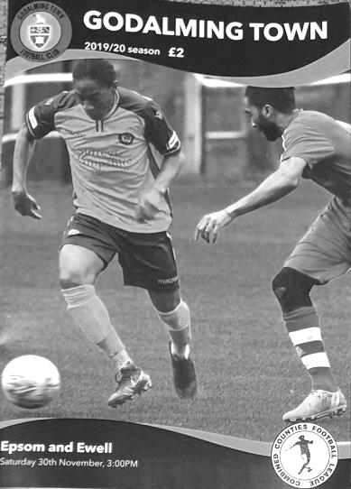
Signs of life at Wey Court

Recent form told us that a trip to Godalming Town would be a difficult proposition. With one win in our last eleven matches, a match against one of the current bottom three clubs could present the most slippery of banana skins, especially as they went into this match with a three game unbeaten run under new Manager Paul Bonner. However, by the end we were comprehensive victors and on another day this could have been quite a heavy victory.

Times have been really difficult in recent seasons as any Epsom supporter will tell you, but the G's have had it tougher still, having fallen from a Step Four position to suffer relegation with us in 2018 and look like they face a difficult battle to survive in Step Six football. We wish them well, although we have hardly helped their plight with Saturday's win being our sixth in a row in under two years dating back to 13th January 2018.

And it was back on that very day that Marlon Pinder made his debut for the club as we won 2-1 at Wey Court with a goal and an assist on his record. Fast forward 22 months and he was at it again, scoring the first and producing a delicious cross for Tariq Straker to notch his first goal for us and clinch the points in the closing minutes.

The day commenced with a couple of milestones as Rob Hendry made his 150th appearance, while Lloyd Connelly was making his 100th and he nearly marked it badly as early as the third minute with a header back to Conor Young that was way too short. But Young stood his ground well and Brown scuffed his shot across goal where another shot was deflected over our bar by a brave defensive block. It was a lucky escape.

The remainder of the opening twenty minutes were even, but in the 15th minute we had some controversy as Pinder sent a great pass over the full back and as Straker latched onto it and ran at goal, Dom Hardisty made a really good challenge on him. Unfortunately, he injured himself in the process and at the same time was adjudged to have fouled our man, also picking up a booking for his troubles. He wouldn't be able to continue much longer before being replaced. I can confirm that it most definitely wasn't a penalty, but justice was done as Bobby Bennett took our spot kick a couple of minutes later and Adrian Giles then saved it, including a follow up from Connelly!

Young had to be alert to claw away a deep cross but we were beginning to get on top by now and James Fray put Bennett through on goal. He drew Giles before squaring the ball to Hendry who was brought down just outside the box in the act of shooting. This earned Andy Tarrent a yellow card that would have consequences later although Hendry's subsequent free kick was blocked wide by the defensive wall. Pinder held off his man well on the half hour although his shot on the turn didn't trouble Giles who was in action again minutes later when a deep Connelly cross was met by Straker at the far post, although the contact wasn't great and the ball was easy to gather.

The goalmouth chances continued and Pinder fed Scott Murphy who was robbed by a defender as

he prepared to pull the trigger and then in the 36th minute Straker made a great crossfield ball for Bennett to run onto, but his shot from eight yards was too close to Giles who blocked the shot. Even after Fray was sent to the sin bin in the 38th minute we continued to threaten as Pinder headed a Joe Bonass-Ward cross narrowly wide after good work from Hendry, although Young had to make a couple of comfortable saves and we then had the bizarre sight of our players going into the corner of the field to waste time as the first half closed. This sin bin rule is not helping the game whatsoever. Clearly the home side weren't particularly happy either and one of the Management team picked up a yellow card as the teams walked off at the break, presumably for something that was said.

Fray re-joined the action 19 seconds into the second half and we would go on to have a substantial number of efforts on goal in this period. Hendry cut in from the right wing but his shot across goal was cleared by the leg of Giles and he was in action again to block a long range Fray strike. However, we nearly conceded in the 51st minute when a home player broke through on goal, but Young blocked his shot and fell on the loose ball.

We went back up the other end and from a promising attack Hendry was clattered into on the edge of the box by Tarrent again who received a second yellow card for the challenge. Then Pinder curled the ball into the bottom corner from the free kick in the 55th minute to exact the maximum penalty and open the scoring. He then set up Fray who passed to Hendry but the speed on the pass was a little slow and Hendo's shot was blocked by a covering defender. Also doing a good job in defence for the home side was former Salt Rory Sellick who had started in midfield before taking Hardisty's place at right back, but then found himself at centre back following the dismissal!

The home side still threatened from time to time and with just a one goal lead and our last away clean sheet being some fourteen months previously, any attack from the home side provided a concern, but Jahmahl King and Todd Murphy repelled anything that came their way. Indeed Murphy nearly registered his first goal for the club at the other end as he met a deep Hendry corner, but Giles just kept out his header at the foot of the post.

Pinder forced a good save from the overworked Giles who was also there to intercept a cross from newly introduced substitute Corey Haywood-Roye but in the 78th minute we had a major scare as a route one ball caught our defence out and Young had to stand his ground well and force the striker to put his shot wide. Then Todd Murphy ended a dangerous run from Reece Weekes in an agricultural manner, taking a yellow card for the team, but at the other end Bennett struck into the side netting from a decent position after receiving a Straker cross. We finally put the game out of reach by scoring our second after Pinder's deep right wing cross was met by Straker's head, with the ball also grazing a defender on the way into the net in the 87th minute. Hendry nearly marked his milestone appearance with a goal as he got through into the penalty area in the 90th minute but was denied by a fine saving challenge and the home side finished with nine men as they were out of substitutes when a player was injured towards the end.

Over the 90 minutes, this was one of our best performances of the season, but much like our other recent clean sheet against FC Deportivo Galicia, it took us a while to finally make the game safe and against a better team, that may have cost us. However, we kept working for the full ninety minutes and were deserving winners by the final whistle. Further performances like this will finally see us climbing the table, even though we remain in fifteenth position following this win.

Epsom and Ewell; Conor Young, Lloyd Connelly, Joe Bonass-Ward, James Fray, Todd Murphy, Jahmahl King, Bobby Bennett, Scott Murphy (c), Rob Hendry, Marlon Pinder, Tariq Straker

Sub: Corey Haywood-Roye for Bonass-Ward (72), George Smith for T.Murphy (88)

From behind the goal
Fleet Spurs 2-1 Epsom & Ewell
Combined Counties League Division One - Saturday 7th December 2019

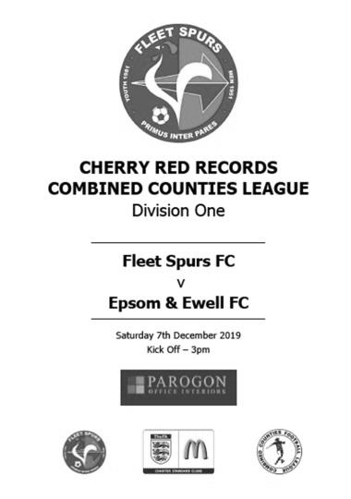
One step forward, two steps back

Any faint hope we had of making a late season run to gate-crash the top four was ended at Kennels Lane on Saturday as the home side completed a league double over us with a 2-1 win. On another day we might have claimed a draw for our second half performance, but our first half showing really wasn't good enough and wiped out all of the good work that had been achieved the week before at Godalming Town.

We had a late change to the line-up as James Fray was not at the match, so Adam Heagney stepped up into the starting eleven after a few weeks out with a facial injury. Otherwise it was the same eleven that had played so well seven days previously, but you wouldn't have known it. The first half opened with a scare in just the third minute when their left winger ran around Todd Murphy, although Murphy did well to hold him up and the ball got away from their man and ran through to Conor Young.

We had a half chance in the 12th minute when a good cross by Tariq Straker was flicked on by Rob Hendry but Bobby Bennett coming in at the far post was unable to get there in time to make the perfect contact and instead he hit the ball on the up, clearing the Fleet bar from inside six yards. This proved costly as we trailed two minutes later when the left winger got through again and provided the simplest of chances for Andre Smith to finish off, giving Young no chance.

The next twenty minutes contained little of real note except that there were a number of physical challenges on our boys that were regularly given as fouls but with no further action from the referee, who in my opinion, should have clamped down on things a little more, but we were creating very little and a rare opportunity came from a right wing Marlon Pinder cross that was met by a bullet header from Straker that just cleared the bar. However, we were still extremely open at the back and Smith broke through on goal once again, only for Young to deny him with a good save.

As the half closed we began to put a bit of pressure on with Mark Appleby in the Fleet goal having to punch the ball away a couple of times under pressure before Heagney was clattered with a nasty foul just outside the area. The free kick was given, yet there was not even a word for the offender, although when Scott Murphy tried to ask him when he was going to start protecting their players, he was the one who ended up

receiving the lecture! Pinder's free kick cleared the top corner of the goal by less than a foot and we went in as we had done at Kennels Lane last year, trailing by a single goal.

Last season you may recall, we trailed 2-0 with just sixteen minutes left, only to win 3-2, but this time we didn't have to wait so long and were level just over a minute into the second half as Hendry got away on the left and delivered a perfect cross that Pinder was able to reach ahead of Appleby, lifting the ball over him into the net from ten yards.

However, despite pushing for a second goal, we then conceded a silly goal at the other end in the 59th minute when it appeared that a pass was on its way through to Young. It's not clear exactly what happened but somehow Smith got to it first and poked it past him into the net for what would prove to be the winner. Should one of our defenders got there first or was Young not out in time? It's hard to say, but there was laughter from some of their players after the goal, so something went a bit wrong along the way.

We tried to fight back. Substitute Taryn Smith received a good pass from Hendry at the back post and cut inside his man, but his shot was well over the bar. Hendry had a try that went just into the near post side netting and Smith also had another try from distance but it too was off target. We could and maybe should have conceded as Smith broke through once again and then rounded Young to leave the simplest of finishes, but made a hash of it and before you knew it, Young had the ball in his hands again.

Hendry saw a shot on target deflected wide before we had a really good chance in injury time as a deep right wing cross was headed back across goal by Hendry to Bennett, but his header back across the keeper had just too much on it and cleared the bar. There was just time for Straker to lose his patience with the referee and he spent the final seconds of the match in the sin bin; our seventh visit of the season, compared to one for our opponents.

Even had Bennett's header gone in, we would have only secured a point against a team we needed to beat if we were to have any chance of climbing the table. Instead we actually slipped a place to sixteenth and yes, now it's time to mention the dreaded "r" word. We may currently have a small cushion on the bottom three, but they have games in hand and right now we face a very serious situation which really shouldn't be happening with the players we have, one of whom Pinder, advised that he would be moving on after this match. In fairness, and on his recent performances for us where he created much and scored three times in five appearances, he was too good for Step Six football anyway. Many other players ought to be in that category with much experience of playing at Step Four and Five, but this performance was a poor one against a team, it should be remembered, that have no playing budget whatsoever.

Epsom and Ewell; Conor Young, Lloyd Connelly, Joe Bonass-Ward, Adam Heagney, Todd Murphy, Jahmahl King, Bobby Bennett, Scott Murphy (c), Rob Hendry, Marlon Pinder, Tariq Straker

Sub: Taryn Smith for Bonass-Ward (55)

From behind the goal
Sutton United Development 0-7 Epsom & Ewell
Surrey Premier Cup – First Round - Monday 9th December 2019
No programme issued

Rampant Salts carve Sutton apart

On a chilly Monday evening, exactly eleven years to the day after a famous Surrey Senior Cup win there against their first team, we handed out a comprehensive seven goal win at Gander Green Lane against the Sutton United Development eleven to at least temporarily banish our recent League woes. The game nearly didn't go ahead as we were really struggling for players on the day of the match, but in the end fourteen were available for this Surrey Premier Cup tie, played with an orange ball, which was a first for the club probably since using an old leather ball in the fifties!

This competition is a strange one. Thrown in with a clutch of teams in our division, there are some Amateur League teams and many Reserve or Development elevens and it is really hard to gauge the strength of many of these teams. Last season we battered Knaphill's development team, yet lost to a much better one representing the Met Police, while Sutton's team were inferior to both, despite many of their players having played in a decent FA Youth Cup run earlier in the season. Indeed, that was the reason this match was delayed to December with all the other ties in this round having already been played.

Of course, part of the reason they looked so inferior was because we played particularly well. Given more space by our opponents than was the case at Fleet Spurs, we tore into them from the start and with just two minutes and four seconds on the clock we were ahead as Rob Hendry's deep corner was headed in by an unmarked Steve Betancourt at the far post.

We continued to press our hosts and Adam Heagney was only a couple of feet wide with a left footed strike from distance and in the 14th minute we extended our lead as a crossfield ball from Scott Murphy was perfectly delivered over the full back where Bobby Bennett's first touch put him straight through on goal and he buried the ball across the keeper into the bottom corner. Two became three just three minutes later as another deep Hendry corner was volleyed at goal by Betancourt and although that shot was blocked, it fell to Liam Roberts to tuck the ball into the far corner from twelve yards.

Although no further goals followed until the conclusion of the half, we kept creating chances and Murphy and Bennett both had shots on goal, the latter on target after good work from Hendry and Roberts on the left, but his shot was blocked. On the half hour Corey Haywood-Roye, making his first start after a cameo at Godalming Town produced a superb low cross along the six yard line, but it was just too far ahead of the incoming Hendry.

As the half ended, Roberts broke through as the ball took a kind bounce for him, although the Sutton keeper did well to block the shot with his legs. It earned him no

reward though, as the subsequent corner was flicked on by Taryn Smith and handled by a defender, so in the 44th minute it was Hendry who stepped up to open his account on the night and retain his 100% record from the penalty spot to give us a four goal cushion at the half.

The second half was also one of almost total control, although the home side never stopped battling away and started to get a little closer to our goal in this period. By that time though, they were 5-0 down as a delightful ball over the top of the defence from Roberts was collected on the left by Hendry and his low delivery took out the keeper and left Bennett with an easy tap in at the far post in the 47th minute.

Bennett had another shot well blocked by the keeper's foot just after this before we had a shout for a second penalty when Tariq Straker's header from a Hendry corner appeared to hit an arm, which looked far too high to be in a natural position but it wasn't given. Hendry returned the favour to Roberts with a clever pass, but Roberts was a little too wide and his flicked effort at goal was blocked by the keeper for a corner. There was even time for Bennett to try something extravagant receiving a good reverse pass from Hendry, but as the hall held up behind him, he spun and tried a backheel from 12 yards which struck the leg of the advancing keeper and fell to safety.

However, little was really safe in the final third in this match and we extended our lead to six in the 69th minute when a pass was unintentionally diverted by a defender straight into the path of Hendry and he finished clinically. Just a minute later it was 7-0 as Roberts put in a good run and drew the keeper, who made a good half save as he tried to round him. The ball fell to Bennett who tried the same, but was brought down by the keeper. It looked harsh from where I was, but the referee was right up with play throughout the match and this was no exception, being in a much better position to see the offence and award the spot kick which Hendry dispatched to complete his hat trick.

Bennett saw his cross blocked for a corner with players waiting and Murphy was unlucky to see his spectacular volley from the corner just clearing the bar from the edge of the area, while in the 89th minute Conor Young had to make his first save of the match; a very comfortable take of a long range strike.

This was a mismatch, pure and simple, but you can only beat who is in front of you and our boys kept pushing for more goals, despite the match being over as a contest inside twenty minutes, so much credit is due there. We now enter the Second round (last 16) of the competition where we will host the powerful Southern Amateur League team Nottsborough, who have been winners and finalists in the previous two competitions.

Epsom and Ewell; Conor Young, Corey Haywood-Roye, Tariq Straker, Adam Heagney, Steve Betancourt, Lloyd Connelly, Bobby Bennett, Scott Murphy (c), Rob Hendry, Taryn Smith, Liam Roberts

Sub: George Smith for Taryn Smith (56), Sam Morgan for Haywood-Roye (72),
Todd Murphy for Betancourt (78)

Centre page for results

Centre page for results

Bedfont & Feltham F.C. – History
Bedfont & Feltham Football club was formed in May 2012 following the amalgamation of Bedfont Football & Social Club with Feltham FC, taking the place of Feltham in the step 6 Combined Counties Division 1. The changes bought some decent results; two 5th place finishes in their first two seasons. The 2015-16 season saw a runners-up spot, three points behind CB Hounslow United and this was good enough for promotion to the Premier Division.

The club only lasted at the higher level for one season, finishing second-bottom and some 13 points adrift of safety. Season 2017-18 saw the club finish in 17th place. In the summer of 2018, Adam Bessent joined from Staines Lammas and their loss was Bedfont & Feltham's gain.

Season 2018-19 started very well for Bedfont & Feltham seeing them unbeaten at the top of the league. Getting off to a cracking start helped: an 11-0 win over Bagshot earned the TalkSPORT 2 'Non-League Team of the Week' award.

The club held their heads high and were one of the forerunners throughout the season; suffering their first league defeat in November. Further losses in January and February saw the crown slip slightly, leading to an eventual fifth place finish.

In the FA Cup, 2015-16 saw the club's best FA Cup run as they beat London Tigers and AFC Hayes (both after replays). A tough test against AFC Rushden & Diamonds awaited them in the 1st Qualifying Round where the run ended, despite a credible performance in the 2-1 defeat. The FA Vase has proved trickier, the best run being the 1st Round in 2013 where they lost 1-0 at Welwyn Garden City. Local cup wins include the CCL Division 1 Challenge Cup, lifted in 2015 as they beat Worcester Park 4-3 on penalties in the final as well as the Middlesex Premier Cup a year earlier.

Adam Bessent has brought in Mark Goff as Coach, and the club is continuing its foray into youth football, with teams from Under 8s to Under 16s.

Season 2019-20 started with a win followed by two straight defeats and a draw. The team has seen an improvement again and has recently surged from mid-table to 4th place.

The Yellows’ Buildbase FA Vase 5-0 win against Lutterworth Athletic was supported live on air by Absolute Radio’s Rock ‘N’ Roll Football. Following this, a visit to Spartan South Midlands side Bedford FC saw a 4-0 win and the club made history by reaching the Second Round Proper after a 3-1 win against Premier Division side Colliers Wood United. Unfortunately, the Second-Round Proper fixture at Welling Town ended in a 1-3 loss after extra-time (1-1 at 90 mins).

The club has also retained the FA Charter Standard.

This Day in History – 14th December
Date | Day | Competition |  | Opponents |  | Scorers
14/12/29 | Sat | London League | A | Whyteleafe Albion | 6-0 | E.Matkin (4), C.Harvey, F.Behn
14/12/35 | Sat | London League | A | Carshalton Athletic | 1-4 | B.Neal
14/12/46 | Sat | London League | A | Eton Manor | 0-5
14/12/57 | Sat | Surrey Senior Cup 1 | H | Sutton United | 2-0 | J.Bangs, J.Sorensen (pen)
14/12/63 | Sat | Athenian League  Division1 Cup 1 | H | Uxbridge | 1-2 | N.Derry
14/12/68 | Sat | Surrey Senior Cup  3q replay | H | Merton Rushmere | 3-1 | K.Jolly, R.Malyon, M.Finch (pen)
14/12/74 | Sat | Surrey Senior Cup 3q | A | Chessington United | 2-2+ | T.Tuite, D.Ritman
14/12/82 | Tue | Isthmian League 1 | A | Wembley | 1-1 | S.Hill
14/12/85 | Sat | Isthmian League  Premier Division | A | Sutton United | 1-3 | T.Tuite
14/12/96 | Sat | Isthmian League 3 | A | East Thurrock United | 2-3 | A.Boxall (2, 1 pen)
14/12/02 | Sat | Isthmian League 1s | H | Met Police | 1-0 | S.Huckle
14/12/10 | Tue | F.A. Vase 3 | H | St Neots Town | 1-2 | D.Stevens
14/12/13 | Sat | Combined Counties Premier Division | A | Wembley | 3-1 | M.Jarman (2), K.Hough
Historical Decades
Date | Day | Competition |  | Opponents |  | Scorers
100 years ago – Epsom Juniors F.C.
06/12/19 | Sat | Surrey Junior League | A | Brighton Railway | 0-9
90 years ago – Epsom Town F.C.
14/12/29 | Sat | London League | A | Whyteleafe Albion | 6-0 | E.Matkin (4), C.Harvey, F.Behn
70 years ago – Epsom F.C.
10/12/49 | Sat | Corinthian League | H | Edgware Town | 3-3 | E.Watkins (pen), A.Graham, G.Brogdale
60 years ago – Epsom F.C.
12/12/59 | Sat | Corinthian League | A | Erith & Belvedere | 3-2 | N.Lewis (2), S.Law
50 years ago – Epsom & Ewell F.C.
13/12/69 | Sat | Athenian League 2 | A | Herne Bay | 2-3 | K.Gregory (2)
40 years ago – Epsom & Ewell F.C.
11/12/79 | Tue | Isthmian League Cup 4 | H | Harwich & Parkeston | 1-2 | D.Walker
30 years ago – Epsom & Ewell F.C.
09/12/89 | Sat | Isthmian League 2s | H | Maidenhead United | 0-2
20 years ago – Epsom & Ewell F.C.
11/12/99 | Sat | Isthmian League 3 | H | Tring Town | 3-3 | G.Morris, R.Sell, B.Stevens
10 years ago – Epsom & Ewell F.C.
15/12/09 | Sat | Combined Counties Premier Division | H | Banstead Athletic | 2-0 | M.Smith, R.Burns
History Corner – 14th December
100 years ago this week we continued to find life tough in the Surrey Junior League, losing 9-0 to the Brighton Railway team in a Surrey Junior League match. They were a very strong team in those early post war years and would eventually reach Senior status too, playing at no less a ground than The Nest, Crystal Palace’s old ground near to Selhurst Station for a season from 1924 where we would meet them in the Surrey Senior League. It’s not clear where they played back in 1919 but here’s the thing, they still exist! They changed their name to Southern Railway in 1924 and in the sixties they merged with Raynes Park. That club merged with Malden Vale in the nineties to become the Raynes Park Vale we know today!

90 years ago today we visited Whyteleafe Albion for a London League match. They were a fairly new team playing at New Barn Way where the stand still existed until recently, despite being part of school playing fields nowadays. E.G. Matkin scored four times for us as we won 6-0 which was an odd result, as they defeated us 6-1 at West Street just five weeks later! Although unconnected, the current Whyteleafe club started out at the same venue before moving to Church Road in the sixties.

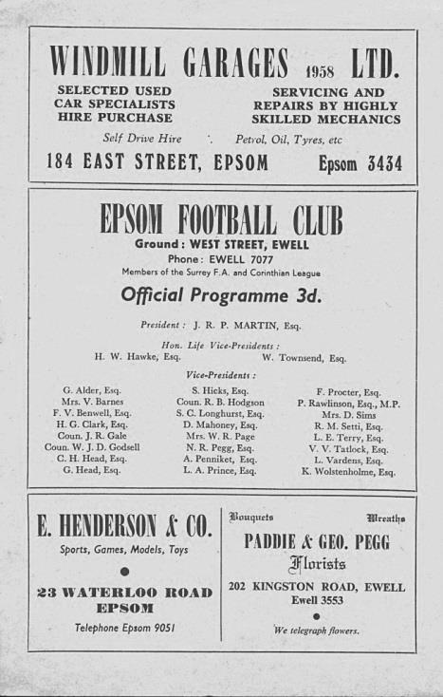
62 years ago today we hosted Sutton United in a Surrey Senior Cup tie, winning 2-0. Both clubs had a number of former players who had played for the other side previously and two of these scored for Epsom as Jorgen “Jan” Sorensen scored a penalty to go with Johnny Bangs’ opener. We wouldn’t meet each other in competition for a further 24 years (see programme pictured)

45 years ago today we were held 2-2 after extra time by Chessington United in the Surrey Senior Cup at Chalky Lane. This was a credible result for the hosts, as this was our stellar year and we had already won there 6-0 in the League, but they held us to a replay and even that was a tight affair seven days later as we squeezed through to a First Round tie at Addlestone.

37 years ago today I felt awful, and had taken the day off school, but still made the journey to Vale Farm for the Tuesday night fixture where we secured a point from a 1-1 draw at Wembley with a late Steve Hill equaliser. Fortunately he wasn’t still my P.E. teacher, or I might have been in trouble!

20 years ago this week we trailed 3-0 at home to Tring Town but fought back to draw 3-3 and actually we had good chances to win the match but couldn’t take them. Graham Morris, Richard Sell and Barry Stevens were our scorers that day.

9 years ago today we played our delayed F.A. Vase Third Round match against St Neots Town at our temporary ground of Moatside, home of Merstham F.C. They were favourites for the whole competition, had plenty of money and even their own television channel, yet we led through Dave Stevens for a while before the visitors, aided by former Aston Villa professional Stefan Moore, got back into the game and took a 2-1 lead that they held onto without much danger. They were very good, yet they got knocked out a round or two later by a team from their own league in the shape of a reformed Kings Lynn.

Player Sponsorship
Here is the latest list of players for 2019/20, with photos showing all of our boys and also our Management team that are available for sponsorship. These will be updated shortly. Thanks as always to our Club Photographer Gemma Jarman.

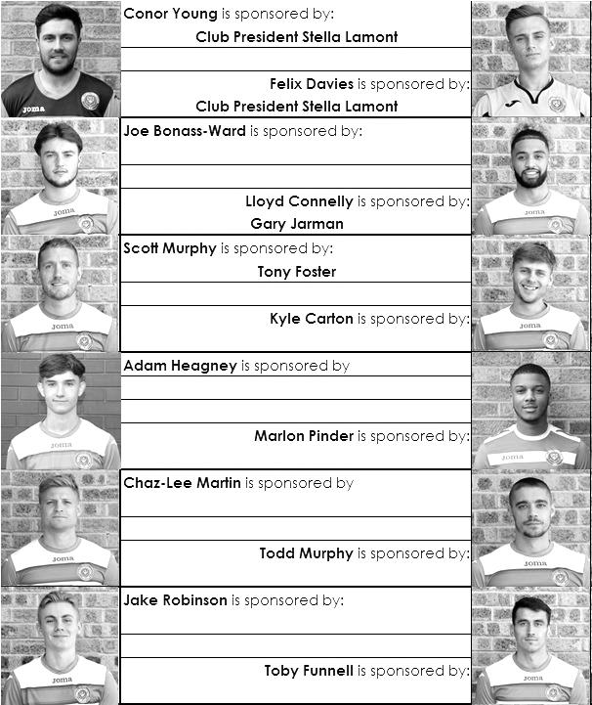

Sponsorship costs just £40 and it is easy to do. Just select a player who has not been previously sponsored and let a Committee Member know that you would like to sponsor them. Beware though. Until we have received the money it is possible for someone to jump in front of you, so don’t delay, sponsor today!

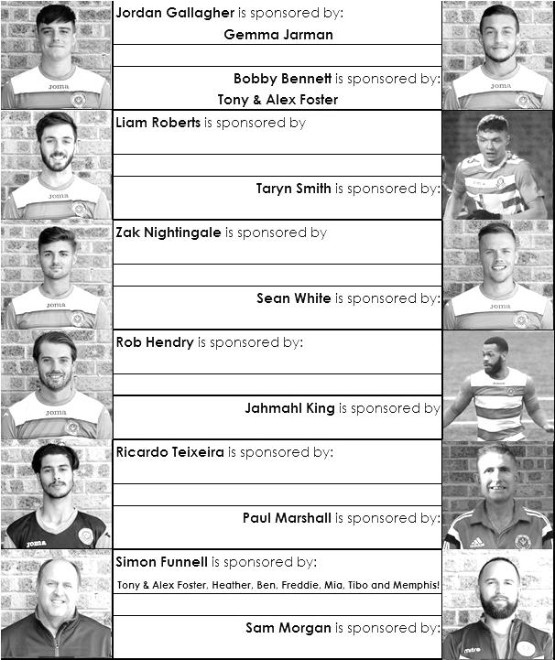

Jersey bound!
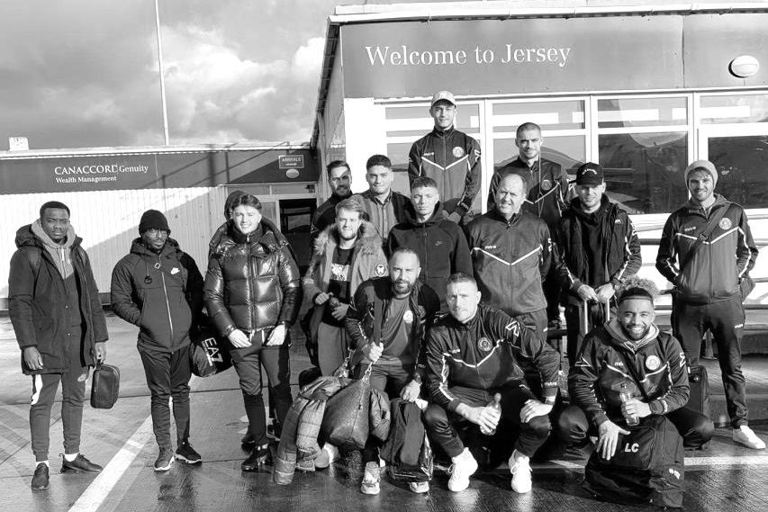
On Saturday 16th November it was our turn to make the long journey to Jersey for the League match against Jersey Bulls and we gathered at Gatwick Airport bright and early at around 6.30 a.m. in good time for the flight at 8.05. There were some new faces as George Smith and Tariq Straker would be making their debuts in this match, and sixteen players including Manager Simon Funnell and the returning Conor Young and Steve Betancourt made the journey and arrived at Jersey Airport around 9.00 a.m.

We were picked up by a pair of minibuses and ferried in to the Springfield Stadium, some five miles across the island from West to East and as you might expect, arriving fairly early!

The players, along with the few officials that had made the journey; myself, Tony Foster, Paul Marshall, Mel Tough and Gary Jarman, as well as Gemma Jarman and Nathan Lambert were left at the café, so the players decided to take a walk into town, where Simon bought a particularly fetching top for the player who had the worst game!

While they were out in St Helier, many of them chose to go into the local William Hill Bookmakers, whereupon Bobby Bennett and Todd Murphy were asked to prove their age. Bennett replied that he was 26, which seemed to do the trick!

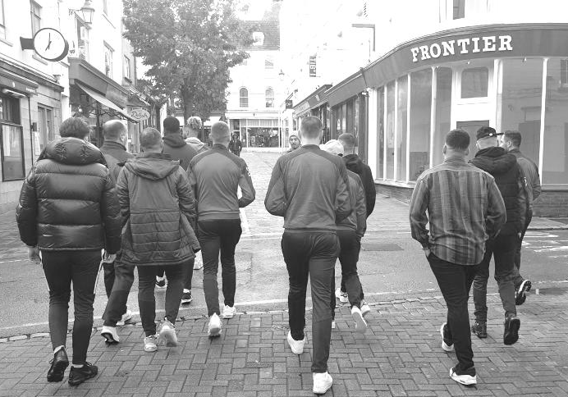
Then it was back to the café for the pre-match lunch which was a large helping of spaghetti. I enjoyed it a lot, but many of the players passed it up for what can only be described as less healthy options!

After lunch the players wandered off again, returning in good time for their warm ups on the artificial surface. Time passed fairly slowly as we waited for the 3pm kick off and then it was time for action.

Obviously the result and report are covered elsewhere within the programme, but it has to be said that we put up a good fight throughout, with Scott Murphy in particular, putting in a shift and covering a large amount of ground throughout the match. We defended well before being penalised for a handball just before the half, and a cruel own goal in the closing minutes of the second half completed the scoring. Despite the result, Nathan kept

supporting our boys from the back of the stand with a rather bemused young Jersey fan in front of him who had clearly never encountered such a young away supporter before!

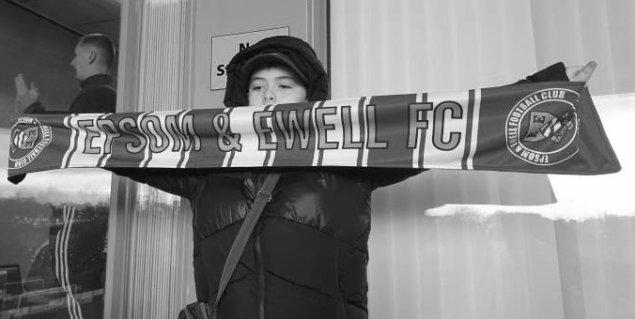
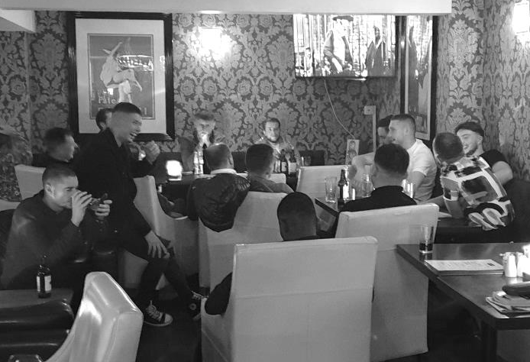
After the game, no one was particularly downhearted as the players had given their all and were now looking forward to the post-match entertainment. Our gracious hosts provided us with a meal after the game and at about 6pm it was time to check into the Hotel de Normandie; a hotel that was used to dealing with large groups of people as I used to stay there around the Millennium for their Festival of Pool events. They based themselves in the Hotel Bar (pictured below) before heading off into the night, where of course what happens in Jersey, stays in Jersey!

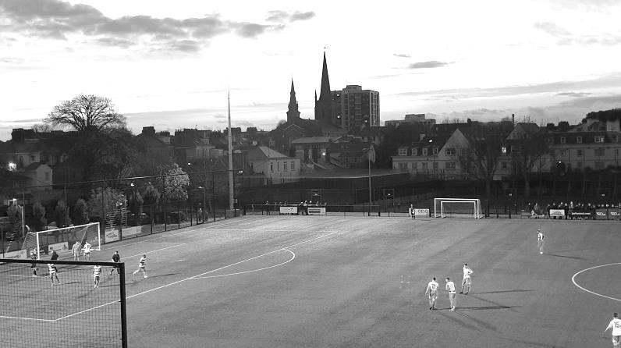
For the rest of us, the evening passed smoothly, with only a fire alarm going off at 6.00 a.m. on the Sunday morning providing any concern. Fortunately this was not down to any of our players, but was merely the fault of the kitchen staff who had set it off by accident!

And all too soon, it was time to go. As the sun set on our adventure, our players knew that all they had to do was finish in the top four this season and we’d get to do it all over again, next season!

Surrey Premier Cup
First Round
Bagshot | 1-3 | Horley Town Reserves
Met Police Reserves | 3-1 | Cobham Development
Godalming Town | 1-3 | Dorkinians
Sutton United Development | 0-7 | Epsom & Ewell
Reigatians | w/o C&H | Chessington & Hook United
Carshalton Athletic U21 | 3-0 | Walton & Hersham
Old Wilsonians | 4-2 | Westfield Reserves
Ash United | 12-0 | AFC Croydon Athletic Development
FC Deportivo Galicia | 2-3 | Dorking Wanderers Reserves
Second Round
Epsom & Ewell | V | Nottsborough
Farnham Town | V | Old Wilsonians
Carshalton Athletic U21 | V | Molesey Development
Abbey Rangers Development | V | Chessington & Hook United
Westside | V | Lingfield Reserves
Met Police Reserves | V | Sutton Common Rovers U23
Ash United | V | Dorkinians
Dorking Wanderers Reserves | V | Horley Town Reserves

Recent Milestones
On Saturday 16th November at Jersey Bulls, Simon Funnell took charge of his fiftieth match as Manager of the club. He joined us as Assistant Manager to Neil Grant in the July of 2018 and moved up in October, following Neil’s dismissal.

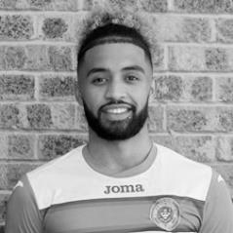
Our next milestone occurred two weeks later at Godalming Town where we had two in one match. Lloyd Connelly made his 100th appearance in our 2-0 win. He joined us from Westfield and made his scoring debut out on the right wing on 14th October 2017, in a 1-1 draw at Camberley Town and has been extremely reliable ever since. Securing 100 appearances in just over two years is very impressive, especially bearing in mind the player turnover during the last couple of seasons. Lloyd is the 126th player to reach this mark and if that sounds a lot, bear in mind that we have had around 1,630 first team players over our 101 seasons, putting Lloyd well inside the top 10% of players in history and he now has eight goals to his credit too!

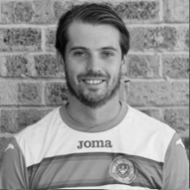
Finally, in the same match Rob Hendry made his 150th appearance. He too made a scoring debut on 8th August 2015 against Windsor, and also in a drawn match, this time 2-2 at High Road. Rob joined us from Glyn Old Boys and is a good cricketer also. He had a couple of spells at Sutton Common Rovers and Chertsey Town after leaving in the summer of 2017, but he re-joined in September 2018 and as a local lad, born in Epsom, he will I’m sure be looking to move higher on the all-time appearance list. He is currently 58th and another 15 matches will result in him joining the top 50 players on the Hall of Fame, where of course he already sits in the scoring charts with 53 goals, following Monday’s hat trick.

Congratulations to all three of you! #saltsfamily

Gordon Sanders 1929 –2019
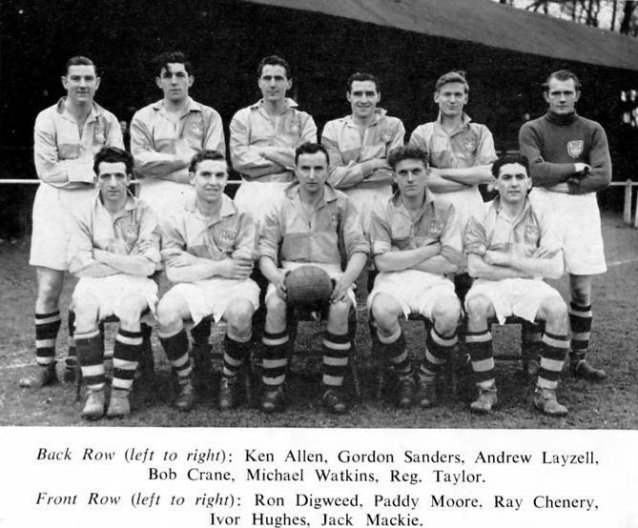
We have recently been advised of the passing on Wednesday 30th October of Gordon Aaron Sanders, who was a member of our Surrey Senior Cup Final team from 1954. He was 90 years old. It has been my privilege to meet four players and the mascot from that team over the years and Gordon was one of these, coming up to Merland Rise to purchase a Club History Book, despite being nearly eighty and living near Eastbourne at the time.

Gordon was born in Wallington on 6th June 1929 and joined us in the summer of 1952 from local club Elmwood Old Boys, spending most of the season in the Reserves. He made his First Eleven debut on 25th October of that year against the Amateur Guildford F.C. club in a Surrey Senior Cup tie which we won 7-0. He escaped any headlines that day due to our striker Bill Goddard getting five goals in that match to start his run of what would become five successive hat tricks.

Sanders took the place of Player/Coach Pat Lynch for this match and the local papers said he “should develop well”. The picture above is a rare one taken of our Reserve Team on 20th December 1952 which was included with a first team picture in a club Christmas Card as an accompaniment to the match programme, but bizarrely wasn’t sent out until 3rd January 1953!

Although he only made another couple of appearances for the first team that season, these were at half back, instead of full back, where the experienced Lynch was always going to keep his place, and it was in this position that he made the bulk of his 63* appearances the following season, culminating in that Surrey Senior Cup Final appearance against Corinthian Casuals at Selhurst Park. He also played in both Semi-Finals against the mighty Dulwich Hamlet at Wimbledon’s Plough Lane

and in the replay at Tooting & Mitcham United’s Sandy Lane ground in front of around 7,000 on each occasion.

As a result the Final itself, watched by “just” 6,159, was a bit of an anti-climax and despite being the better side by most people’s analysis, we conceded once in each half to a team that would be fielding a number of their players just two years later in the Amateur Cup Final at Wembley Stadium, where they would hold the best team in non-league football Bishop Auckland to a draw before losing the replay in Middlesborough.

He made 16 appearances in 1954/55 but found himself back in the Reserves for much of his time at the club and made just thirteen further appearances over the next four seasons before departing in 1959., Reserve team line ups are very hard to find and I only have around twenty confirmed appearances, although my guess is that he probably made well over a hundred for us.

Although I do not know the fate of all the squad from the photo below, I am aware that our keeper, Geoff Porter and the mascot, Roy Oldaker are still alive. Geoff is nearly 88 while the young mascot is now in his mid-Seventies!

Gordon’s funeral was on Friday 6th December in Morden. In our one hundred year history, only 211 out of our 1,630 players have made more appearances and he is thoroughly deserving of recognition within these pages at this sad time.

* Gordon made 63 First Team appearances that I can trace, although there are two line ups in 1954/55 where I have been unable to obtain full line ups and he may well have played in either or both of these matches.

Gordon Sanders - 6th June 1929 – 30th October 2019 – First Team Win Ratio – 46.03%

Match and Ball Sponsorships – 2019/20
Opponent | Date | Match Sponsor | Ball Sponsor
Fleet Spurs | 03/08/19 | Club President - Stella Lamont
Godalming Town | 20/09/19 | Paul Merritt
Tooting Bec | 27/09/19 | EEFC Management Committee
Kennington (FA Vase) | 31/08/19 | Geoff Dyke – celebrating his 70th birthday
AFC Hayes | 21/09/19 | Alex McKay (senior)
Farnham Town | 28/09/19 | Philip Harris
FC Deportivo Galicia | 19/10/19
Dorking Wanderers Res | 23/11/19
Bedfont & Feltham | 14/12/19
Westside | 28/12/19
British Airways | 11/01/20
Kensington & Ealing Borough | 21/01/20
Cove | 25/01/20
Sandhurst Town | 28/01/20
Ash United | 08/02/20
Chessington & Hook United | 22/02/20
Eversley & California | 21/03/20
Walton & Hersham | 31/03/20 | Tony Foster
Bagshot | 04/04/20
Jersey Bulls | 13/04/20 | Club President - Stella Lamont
Match sponsorship costs just £60.00!

Sponsorship includes:

Admission, programmes and hospitality for three people.

A full page advert in the programme and mascot for the day (if required).

Also, you get to choose the player of the match, who will receive a prize

If you are interested, just speak to a Committee Member,
or drop me an email at: richard.c.lambert@gmail.com

Combined Counties League Division One
Opponents All-time Records
inc 7th December 2019 | P | W | D | L | F | A | PPG | GD | Best  Win | Worst  Loss
Westside | 1 | 1 | 0 | 0 | 3 | 1 | 3.00 | +2 | 3-1 | -
Godalming Town | 8 | 7 | 0 | 1 | 22 | 11 | 2.63 | +11 | 5-1 | 0-3
Bagshot | 4 | 3 | 0 | 1 | 12 | 3 | 2.25 | +9 | 7-1 | 1-2
FC Deportivo Galicia | 4 | 3 | 0 | 1 | 10 | 4 | 2.25 | +7 | 3-0 | 0-2
Bedfont & Feltham | 6 | 4 | 1 | 1 | 26 | 15 | 2.16 | +11 | 9-2 | 1-3
Ash United | 22 | 12 | 4 | 6 | 52 | 33 | 1.82 | +19 | 6-0 | 0-3
Cove | 37 | 17 | 10 | 10 | 82 | 60 | 1.65 | +22 | 7-0 | 1-6
Chessington & Hook | 30 | 13 | 9 | 8 | 63 | 45 | 1.60 | +18 | 6-0 | 1-3
Walton & Hersham | 55 | 25 | 11 | 19 | 108 | 111 | 1.56 | -3 | 8-0 | 0-8
Farnham Town | 20 | 9 | 4 | 7 | 32 | 33 | 1.55 | -1 | 3-0 | 1-4
British Airways | 2 | 1 | 0 | 1 | 5 | 5 | 1.50 | 0 | 3-2 | 2-3
Eversley & California | 2 | 1 | 0 | 1 | 2 | 2 | 1.50 | 0 | 1-0 | 1-2
Dorking Wanderers Res | 3 | 1 | 1 | 1 | 8 | 7 | 1.33 | +1 | 3-0 | 3-5
Sandhurst Town | 17 | 7 | 0 | 10 | 29 | 31 | 1.24 | -2 | 4-0 | 1-3
Tooting Bec | 4 | 1 | 1 | 2 | 7 | 9 | 1.00 | -1 | 3-1 | 1-4
Fleet Spurs | 4 | 1 | 1 | 2 | 8 | 10 | 1.00 | -2 | 3-2 | 3-5
AFC Hayes  (inc Brook House) | 13 | 2 | 4 | 7 | 19 | 24 | 0.77 | -5 | 7-0 | 1-4
Kensington Borough | 3 | 0 | 1 | 2 | 3 | 9 | 0.33 | -6 | - | 1-5
Jersey Bulls | 1 | 0 | 0 | 1 | 0 | 2 | 0.00 | -2 | - | 0-2

Combined Counties League – Division One
Saturday, 14th December 2019 - Kick-off 3.00 p.m.
Epsom and Ewell  (Royal Blue & White hoops) | V |  | Bedfont & Feltham  (Red and White Stripes)
Squad | NUMBERS |  | Squad
Conor Young |  |  | Kavanagh Keadell
Steve Betancourt |  |  | Okera Lewis
George Smith |  |  | Billy Nutbeam
Reisse Griffin |  |  | Tom Betts
Adam Heagney |  |  | Elliott Hayden
Lloyd Connelly |  |  | Charlie Dunckley
Jahmahl King |  |  | Kelvin Karanja
Chaz-Lee Martin |  |  | Pete Davis
Joe Bonass-Ward |  |  | Michael Capon
Todd Murphy |  |  | Ross Nunn ©
© Scott Murphy |  |  | Fortune Msamala
Corey Haywood-Roye |  |  | Gilmar Rodriguez-Galean
Jake Robinson |  |  | Nick Hardu
James Fray |  |  | Farhad Mahboudi
Tariq Straker |  |  | Ashley Hitchinson
Toby Funnell
Bobby Bennett
Rob Hendry
Taryn Smith
Simon Funnell | MANAGER |  | Adam Bessent
Sam Morgan / Paul Marshall | ASSISTANTS |  | Jake Bessent
Sam Morgan | COACHES |  | Mark Goff
Sam Morgan | PHYSIO |  | Andy Nolan
REFEREE: M.Hussein
ASSISTANTS: C.Angol, M.Harris

OUR NEXT VISITORS TO HIGH ROAD
Westside
Combined Counties League – Division One
Saturday, 28th December 2019 – Kick-off – 3.00 p.m.

